**How to add a Case Transfer case note**

Step 1

Click on **Case Notes** on the demographics tab



Step 4

Step 3

Step 2

To notify other users click **Self**

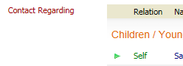

Enter Contact Date and Type of Contact **Case Transfer**

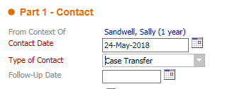

Click **Add Case Note**



Search for the Care Management Transfer basket you require

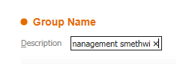

Care Management-

- Oldbury Transfers

- Smethwick Transfers

- Rowley Transfers

- Tipton Transfers

- Wednesbury Transfers

- West Bromwich Transfers

Click **Select another user to be notified**

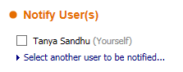

**THIS STEP MUST BE COMPLETED TO ENSURE USERS ARE NOTIFIED THAT THE CASE NOTE HAS BEEN PUT ON TO THE SYSTEM**

Step 8

Step 7

Step 6

Step 5

Click **Confirm**



Click on **All Groups** on the address book options



Step 12

Step 10

Step 11

Step 9

Continue process to include any other users to notify

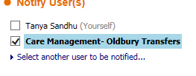

Click **Update**



Click **Finalise** to finalise case note



Enter case note details

