**How to create a Chronology**

Step 1

Step 2

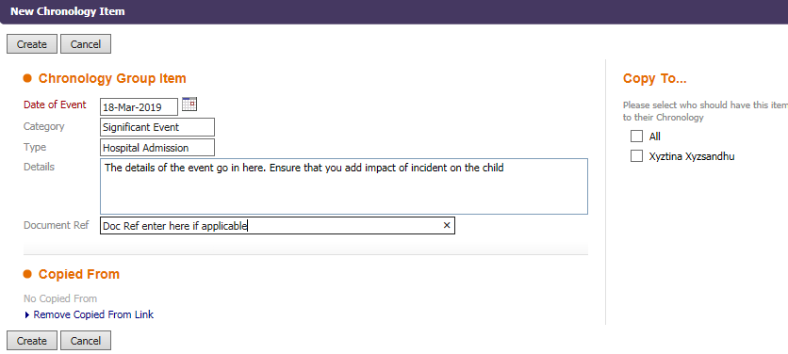

Enter details into fields and click on Create

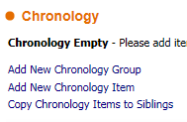

Click on **Add New Chronology Item**

Step 3

Step 4



**Events can be pulled through from the history tab by clicking on the + sign which will display in Chronology however it is important that you elaborate on this event to ensure you add details and impact on the child**

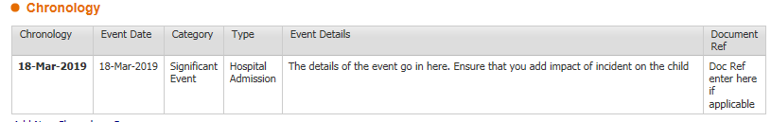

Details will display in Chronology

Step 6

Step 5

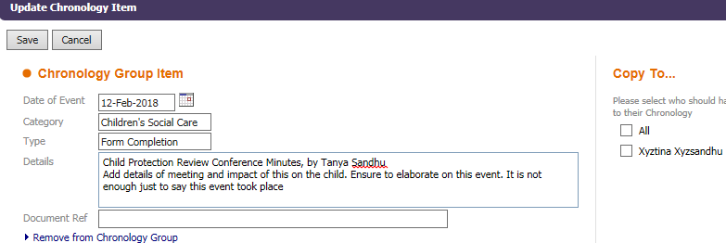

Open up the event on the chronology to add further information into the event details and then click save

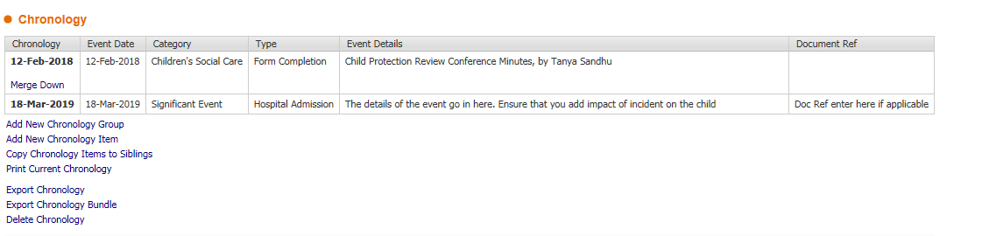

The event will then be added to the Chronology with the additional information.