

**QRG**

**Consolidation**

**Quick Reference Consolidation**

**LCS**

**Consolidating at the start of a stage:**

Consolidation should be completed at the start of a stage. To consolidate a new piece of work:

* Ensure relationships are recorded.
* At the start of the form/ stage, at the bottom it will display all relationships. Those that will be consolidated in this form will have a tick next to their name.

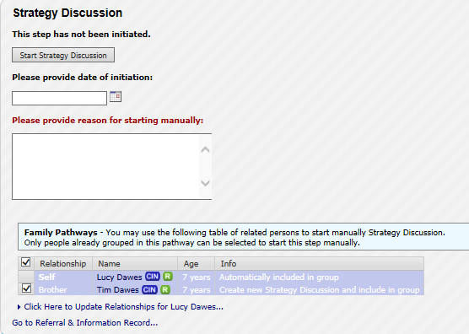

* A form that has been successfully consolidated at the beginning will have the child/s names across the top of the form in a yellow banner:

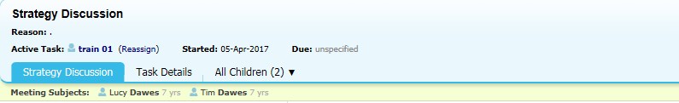

**Consolidating a form *after* it has been started:**

* The missing record will need to be bought up to the same stage as the remainder of the group. i.e. contact, referral, single assessment, strategy discussion.
* Ensure the siblings are grouped at referral.

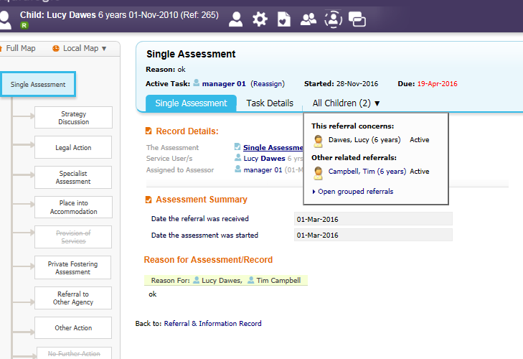

* Within the single assessment select the **consolidation** tab and tick the box next to the missing record.

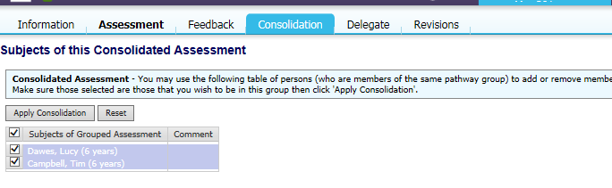

**Consolidating a meeting *after* it has started**

* The missing record will need to be bought up to the same stage as the remainder of the group. i.e. contact, referral, single assessment, strategy discussion.
* Ensure the siblings are grouped at referral.
* In the meeting screen ***before*** the outcomes are started, select add children to this meeting.

