2.Newsletter Covid-19 SCAMS
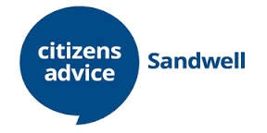
SCAMS SCAMS SCAMS SCAMS SCAMS SCAMS SCAMS SCAMS SCAMS

We recognise that at this time it may be one of increased financial pressure for most people.
Now that the majority of the country will be working from home, it gives scammers a new opportunity to think of ingenious ways to gain access to data. We cannot stress enough the importance it is to remain vigilant at these times. If you receive a call you're not expecting terminate it immediately. If you receive an email that looks suspicious don't click on any links or attachments.
Take a look and see what you can share with the people you care for, friends, family & colleagues.
Most importantly stay safe …. and some tools to help…

1. Check if something is an online Scam - Have a go at the On-Line Scams Helper .https://www.citizensadvice.org.uk/consumer/scams/check-if-something-might-be-a-scam

2. Scams - Key facts and all the data https://docs.google.com/document/d/1lTnWQ6LR0wTT3YqJyYW4qEnc3D5meaBZ3J9M19HdVHo/edit

3. Get help with online - Find out how to contact our Scams Helpline Service for advice
https://www.citizensadvice.org.uk/ScamsAction/

4. Reporting a Scam - Action Fraud can get the National Fraud Intelligence Bureau to investigate scams. They'll also give you a crime reference number, which can be helpful if you need to tell your bank you've been scammed. Read our advice on trying to get your money back after a scam.
It's quickest to report a scam to Action Fraud online, but you can also report the scam by phone.
Action Fraud Telephone: 0300 123 2040

Have a look at this latest SCAM WARNING from ActionFraud
If you want to read more follow the link
https://www.actionfraud.police.uk/alert/coronavirus-related-fraud-reports

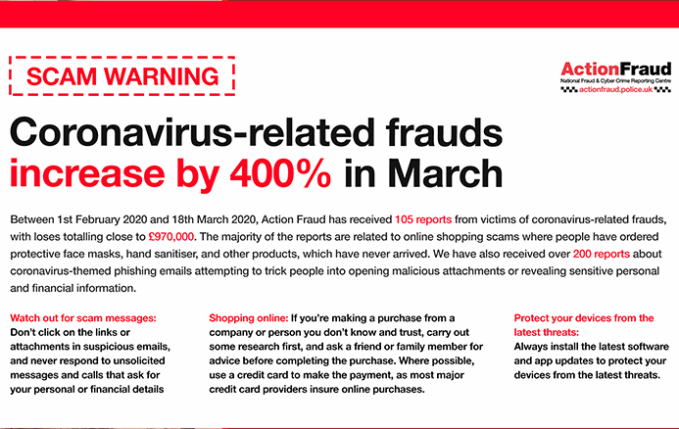Janet
March 2020
Better Off Sandwell
https://sandwell.betteroff.org.uk/#/home

