23 April 2020
Foster Carers Newsletter

message FROM HEAD OF SERVICE
As always, I hope that you are all continuing to keep safe and well at this extremely difficult time. I cannot thank you enough for the care that you are giving some of the most vulnerable children in Sandwell at this time. We want to work with you to ensure that you have the support that you need in order to continue to provide the highest level of care to our children. I hope that you all received the letter that I sent earlier this week which confirmed that the Management Board of Sandwell Children’s Trust made the decision to recognize our foster carers as keyworkers. We have sent out a generic letter to you and we are in the process of now sending you personalized letters confirming your status as keyworkers. I hope that this helps you throughout this restricted period.
I’m conscious that you have received many links to various online resources over the last three weeks. I hope that you have found the links helpful but I’m very conscious that we would not want to overload you. Therefore, this week we are only sharing updates that have arisen during this week. As promised, we will continue to keep in touch on a weekly basis during this unprecedented time.
Thank you once again for the continued care and support that you provide to our children and young people each and every day.
Shanti Eaves
Head of Service, Children in Care, Care Leavers and Fostering.

CONTACT ARRANGEMENTS FOR CHILDREN IN FOSTER CARE
Due to the ongoing impact of coronavirus (Covid-19), and the announcement from the Government on Thursday 16th April to extend the ‘stay at home’ rules for a further three weeks, we have had to take the decision to continue temporary suspension all supervised contact arrangements organized through our Contact Centre. This is in line with the ongoing Government advice to prevent the spread of coronavirus. Due to the congoing levels of risk to public health, our duty of care towards yourself, your family and children must take precedence.

Where contact arrangements have been determined by the courts, the courts will expect alternative arrangements to establish and maintain regular contact within the Stay at Home Rules. It is however important that the spirit of the order should nevertheless be delivered by making safe alternative contact arrangements. We will therefore expect that all indirect forms of contact between children and their parents / family members, including the use of Skype video calling, facetime and/or telephone to continue to be facilitated and promoted. If you have any concerns about this, we ask that you contact your supervising social worker to discuss this.

participation team update
Get creative!
Last week that we had a competition for children and young people to draw or make something to do with Easter. We have had some lovely entries including this one!
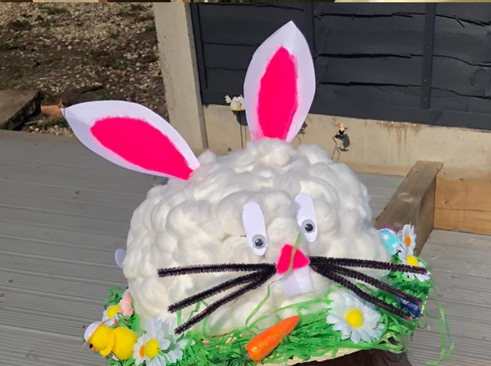

The children who entered will all be getting an Easter Egg and colouring book.
If you missed this, don’t worry as the Participation Team are launching their second competition today, encouraging our children and young people to dance, sing, draw, rhyme…in fact anything they like as long as it’s creative. There are some great prizes on offer, and a great opportunity for the children you care for to express themselves…about anything they like.
Whether it’s a photo, a voice note, a film clip or a drawing, please send any entries to Participation_Team@sandwellchildrenstrust.org

EDUCATION UPDATE
A joint message from Balwant Bains and Shanti Eaves:
You may have heard through the news that on 19th April 2020, the Government made an announcement aimed at supporting vulnerable children to access online learning during the extended lockdown period.
Mr Gavin Williamson (Secretary of State for Education) promoted:
The national on-line learning resources at the Oak National Academy created will provide 180 video lessons each week, across a broad range of subjects from maths to art to languages, for every year group from Reception through to Year 10.

https://www.thenational.academy/online-classroom

The BBC has also launched its own education package across TV and online, featuring celebrities and some of the best teachers – helping to keep children learning an supporting parents.
https://www.bbc.co.uk/bitesize/dailylessons
He also announced his desire to make sure that as many young people in year 10 from disadvantaged backgrounds, care leavers and children with social workers (including families with pre-school age children) are provided with laptops or tablets. Additionally, 4G routers will be available if children attend secondary school and families do not already have mobile or broadband internet in the household; to get them connected while schools are closed.

The devices and 4G routers will be owned by local authorities and schools once they have reopened. However the details of how these packages will be delivered has not yet been announced. I wanted to let you know that we are working with our colleagues in the wider council to clarify exactly what resources will be available to support vulnerable children and we will update you once we are clearer about the resources that will be available. If you have any queries, please direct them to your supervising social worker or Virtual School Education Development Officer.

If you wish to see details of the announcement, you can find it here:
www.gov.uk/government/news/new-major-package-to-support-online-learning

Balwant Bains
Headteacher, Sandwell Virtual School
For Children in Care
0121 569 2770

Shanti Eaves
Head of Service,
Children in Care,
Care Leavers and Fostering.

CONTACT US – IT’S YOUR NEWSLETTER!
This is your newsletter, so do you know about any great fostering resources, or perhaps just an article or web link you want to share? Anything that could be useful to fellow foster carers – we’ll help you let them know.
Or if you have an idea, comment or request about fostering in general or what should be in your newsletter, contact your allocated Supervising Social Worker or email us at Fostering_Info@sandwellchildrenstrust.org

