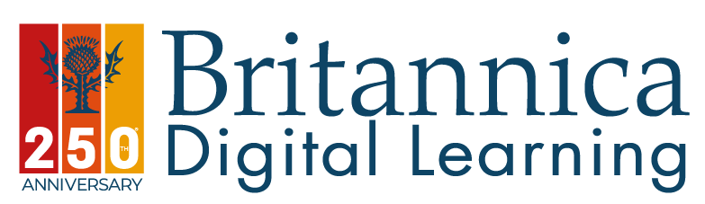
Dear Foster Parent,
Your Virtual School has subscribed to Britannica for any looked after child or family member who is within your care.

At Britannica we understand how challenging getting homework started and finished on time can be.

Start using Britannica as your learning resource and you will find a safe world where truth is the outcome!

Britannica offers what no other search engine can: inspiring curiosity in children and foster parents alike, Britannica is updated every 20 minutes by a team of over 60 editors, our articles are curriculum mapped, differentiated and translated into over 120 languages. Explore the world without fake news!
Britannica School is a perfect match to the new Inspection Framework We have covered the depth and breadth of the curriculum, supporting student-led inquiry, whilst also ensuring pupils develop core skills and subject-area mastery. The idea is that as students dive into content, they build on skills and knowledge achieving clearly defined evaluation points at the end to measure their learning.

To access, go to:
https://register.britannica.co.uk/Sandwell_Virtual_School/
(ID number: Sandwell)

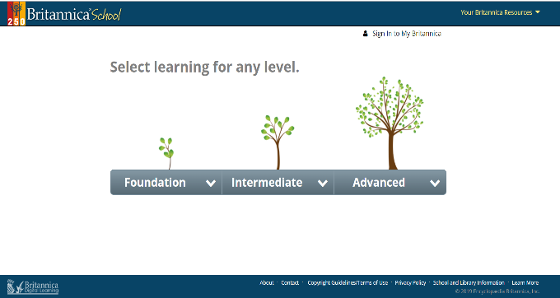

Best Regards
Amy Woodhams
Account Manager
 020 7500 7826|  awoodhams@britannica.co.uk |  www.britannica.co.uk

