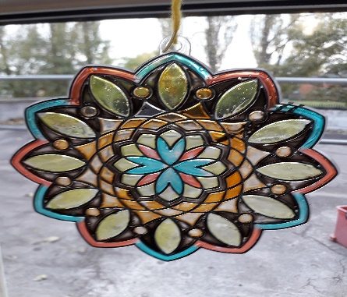
Calling All Young Artists!!!
Ages: All ages
Open to: All Children in Care and those living with them
Mediums: All
Closing date: Friday 4th September 2020 @ 4pm – extended date for all
Being stuck indoors doesn’t mean you can’t have fun!
The Sandwell Virtual School for Looked after Children/LACE team is inviting all Looked after children and those living with them to enter our Young Artists Competition 2020.
The theme is ‘Happiness is…’ Draw, paint, or make something that makes you feel happy! You may use any media you wish - just have fun and be creative! All ages and abilities are very welcome to enter.
All pieces of work submitted will be acknowledged with a certificate of merit. Category winners will be invited to our Virtual School’s Celebration Event which will take some time during the Autumn term 2020. (date to be confirmed) to receive their certificates and prizes.
Following this event, ALL artwork will be displayed in council buildings around sandwell and you will be invited to see your piece of work on display.
Please keep your work in a safe place once completed, and we will contact you nearer the closing date with details regarding how to get it to us.

Any questions, please feel free to contact me

Mobile: 07889735443
Email: helen_hardwick@sandwell.gov.uk

Many thanks , be happy!
Helen

