**Setting up an email footer:**

In your Outlook inbox, select ‘File’ and from the drop down menu select ‘Options’

That will bring up this box:

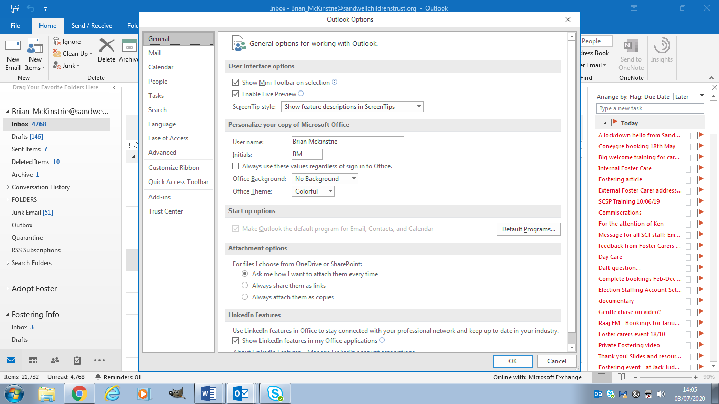

Select ‘Mail’

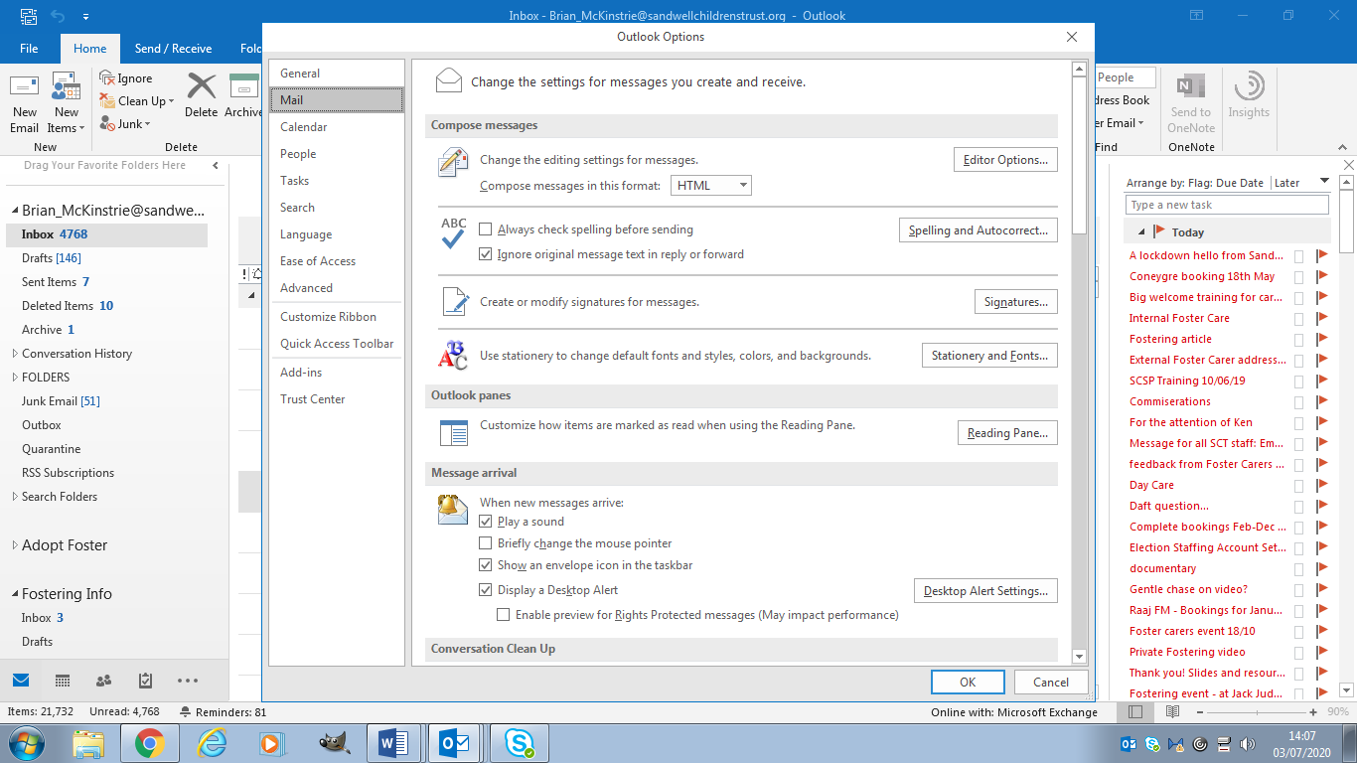

Now select ‘Signature’

This opens up the box to create an email signature:

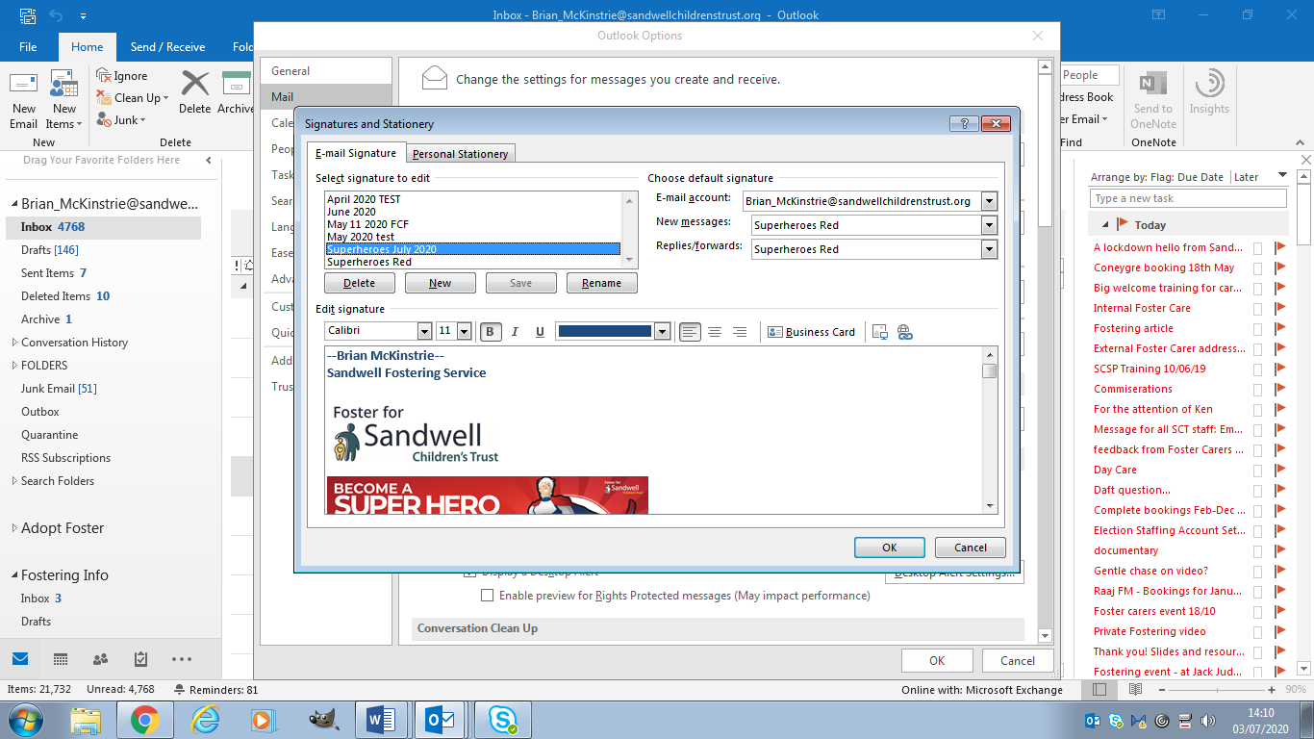

First select ‘new’ and give your signature a name. Then add your new signature tin the bottom box (hint: it might be worth copying & pasting your existing signature and then adding the footer you want to use)

The two footers for the superheroes campaign are:





Choose one and paste it into your signature from this Word document.

Once you have done that and saved it, remember to select it as your default signature for New messages and Replies/forwards from the drop-down menus on the right of this box:



Press OK to exist. You can use the same process to change / update your email signature at any time.

(Hint: Saving a standard signature as your default to revert back to may be a good idea.)